**Resources (to be hosted under the Partner page)**

To make things easier, we have created a range of resources for you to promote being a MobileMuster collection partner. Use our recycling poster to promote your MobileMuster collection unit. (link to https://www.mobilemuster.com.au/recycling/)

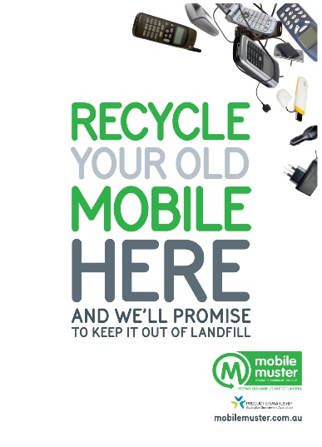

**EDUCATION**

Share our learning resources and educate your community about our recycling process and why recycling matters. (link to mobilemuster.com.au/education)

Before recycling it is important for customers to remove their personal information from their mobile if it is still working. Share our data management tips on how to back up your data and perform a reset.

(link to https://www.mobilemuster.com.au/recycling/)

**PROMOTION**

Use our logo, approved images and video to promote being a MobileMuster collection partner. If you require another file format, please drop us an email. (link to email [mobilemuster@amta.org.au](mailto:mobilemuster@amta.org.au))

(link to logo files)

(link to images)

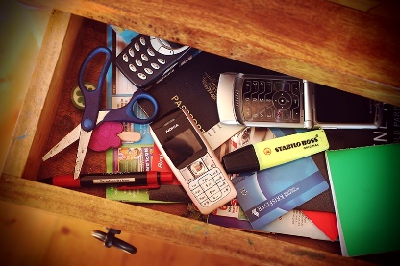 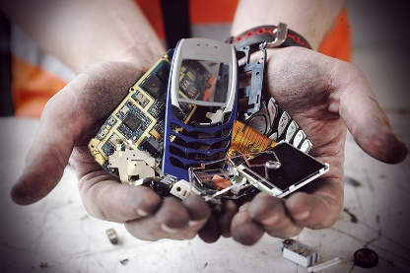

Embed the MM promise video

<iframe width="560" height="315" src="https://www.youtube.com/embed/oPdTMpNDpwk" frameborder="0" allow="autoplay; encrypted-media" allowfullscreen></iframe>

**Social Media**

Be sure to tag **#mobilemuster** on social media, and check out the latest posts using #mobilemuster.

Find us at @mobilemuster on [Facebook](https://www.facebook.com/mobilemuster) and @mobilemuster1 on Twitter, Instagram & [Youtube](https://www.youtube.com/user/MobileMuster1).

**ANNUAL RESULTS**

Annual results on how much your organisation recycled through the MobileMuster program are sent around August each year. These results cover the previous financial year and detail the environmental benefits of recycling. Feel free to share these results with your staff and community.

**MEDIA**

For media enquiries and opportunities please contact Spyro Kalos, Manager Recycling, MobileMuster.

(link to email mobilemuster@amta.org.au)